**Abstract Format To 30ª CSBMM Submission**

First Author1*, Second Author1, Third Author².

¹First Institution, ² Second Institution   
*email@corresponding.author

Times New Roman, 12 point, alignment justified (left and right). Write the text in just one paragraph. Use metric system (SIU) only. [1,2]. Lorem Ipsum is simply dummy text of the printing and typesetting industry. Lorem Ipsum has been the industry's standard dummy text ever since the 1500s, when an unknown printer took a galley of type and scrambled it to make a type specimen book. It has survived not only five centuries, but also the leap into electronic typesetting, remaining essentially unchanged. It was popularized in the 1960s with the release of Letraset sheets containing Lorem Ipsum passages, and more recently with desktop publishing software like Aldus PageMaker including versions of Lorem Ipsum. Lorem Ipsum is simply dummy text of the printing and typesetting industry. Lorem Ipsum has been the industry's standard dummy text ever since the 1500s, when an unknown printer took a galley of type and scrambled it to make a type specimen book. It has survived not only five centuries, but also the leap into electronic typesetting, remaining essentially unchanged. It was popularized in the 1960s with the release of Letraset sheets containing Lorem Ipsum passages, and more recently with desktop publishing software like Aldus PageMaker including versions of Lorem Ipsum. Lorem Ipsum is simply dummy text of the printing and typesetting industry. Lorem Ipsum has been the industry's standard dummy text ever since the 1500s, when an unknown printer took a galley of type and scrambled it to make a type specimen book. It has survived not only five centuries, but also the leap into electronic typesetting, remaining essentially unchanged. It was popularized in the 1960s with the release of Letraset sheets containing Lorem Ipsum passages, and more recently with desktop publishing software like Aldus PageMaker including versions of Lorem Ipsum. Indicate references in the text with Arabic numbers in square brackets, preferably at the end of the sentence, before the period. References must be included with the appropriate reference styles for proceedings abstracts [1], journal articles [2], and books [3]. Acknowledgments are included in the last reference, which is cited at the end of the last sentence of the text on the first page [4].Collect references at the end of the text, on page 1 or page 2. For three or more authors, use first-named author's name plus “et al.” (See references 1 and 3 below). Do not use underlines on publication titles; use italics. Acknowledge sponsorship or support should be the last reference, corresponding to a numeral at the end of the text.

[1] H.G. Hansma et al., Microsc. Microanal. 5 (Suppl. 2) (2002) 1012.

[2] M.A. Rodrigues, Thin Soli Films, 6 (2000) 1192.

[3] J.I. Goldstein et al., Scanning Electron Microscopy and X-ray Microanalysis, Plenum, New York, 1992.

[4] This research was supported by CNPq (Brazil).

**Table 1.** Table 1 legend

|  |  |  |
| --- | --- | --- |
| **Content** | **Content** | **Content** |
| content | content | content |
| content | content | content |
| content | content | content |
| content | content | content |

table 1 references.

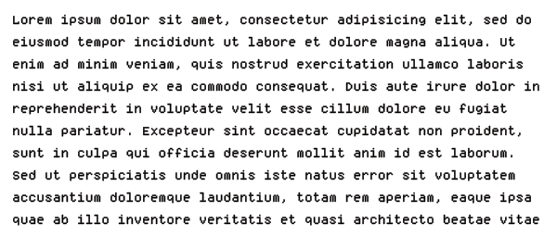

**Figure 1.** Figure 1 caption.



**Figure 2.** Figure 2 caption.